**Ideation Phase**

**Define the Problem Statements**

|  |  |
| --- | --- |
| Date | 03 November 2022 |
| Team ID | PNT2022TMID50604 |
| Project Name | Personal Assistance for Seniors Who are Self Reliant |
| Maximum Marks | 2 Marks |

**Customer Problem Statement :**

It is very difficult for the senior citizens (elder people) to remember their medicines. To avoid the skipping up the medicines, they can be remembered by using the voice commands of the medicine names at correct time specified. If the voice commands on the medicine name is not available, they are given the reminder of the medicine by SMS on their phone or to their closest person.

**Example:**

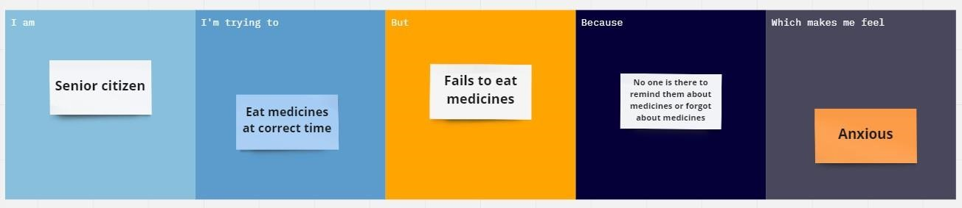

|  |  |  |  |  |  |
| --- | --- | --- | --- | --- | --- |
| **Problem**  **Statement (PS)** | **I am**  **(Customer)** | **I’m trying to** | **But** | **Because** | **Which makes me feel** |
| PS-1 | Senior citizen who is self-reliant. | Eat medicines at correct time | Fails to eat | No one is there to remind about medicines or forgot by themselves | Anxious |
| PS-2 | Senior citizens who is self-reliant | Take injectable glucagon for low sugar at correct time | Lifestyle challenges, forgetting  Of medicine use | Due to forgot by themselves leads to the health risk | Worry about patients  health for careless of taking medicines due to forgotten |